**E-Commerce Website**

**Project Abstract**

**Version 2.0**

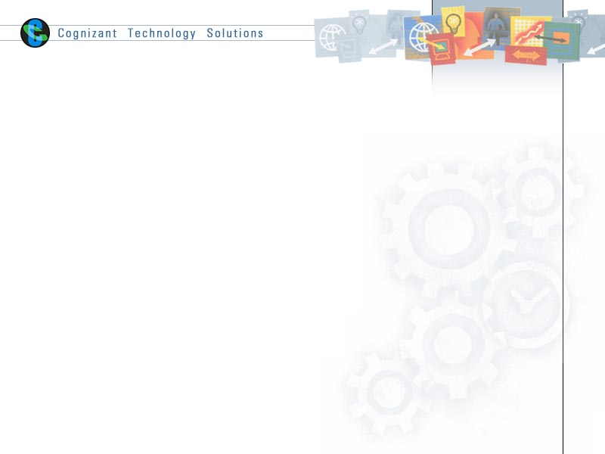

|  |  |  |  |
| --- | --- | --- | --- |
|  | Prepared By / Last Updated By | Reviewed by | Approved By |
| Name | Kushal Pendse (2225486)  Bhavik Bhatt (2225317)  Sahil Kakani (2225472)  Parth Yelne (2225347)  Vinodh Karri (2225267)  Billu Sisindri (2225488) | <Trainer/Project Governance Representative/Cohort Mentor to fill> | <Trainer/Project Governance Representative/Cohort Mentor to fill> |
| Role | CSD Intern |  |  |
| Signature |  |  |  |
| Date | 14/12/2022 |  |  |

Table of Contents

1.0 Purpose of this document 4

2.0 Business Case 4

2.1 Modules 4

3.0 Appendices 5

3.1 Glossary 5

4.0 Terms & Conditions 5

5.0 Change Log 6

# Purpose of this document

This document provides an overview about the business need and the solution that can be provided to fulfil the objective.

# Business Case

The e-Commerce Website is a place where people can find different accessories, home appliances, electronic devices and vegetables. There will be a wide variety of collections on each of the above mentioned categories and customers will be able to filter out their choice from the available ones.

It will be a simple and user friendly application which can be used by anyone to buy their products, pay online and track their delivery thereafter at real time.

## Modules

* **Home Page**
* The page where the users can view the products but won’t be able to buy it unless they register and log in themselves into the application.
* **Registration Page - Admin**
* Admin will be able to create their accounts based on the required fields to be filled appropriately.
* They will also be able to delete their account.
* **Login Page – Admin**
* After entering correct credentials, the admin will be able to log in.
* They will be able to view the available quantity which they are selling and can increase or decrease the amount based on their requirement.
* They will also be able to see the star ratings and feedbacks regarding their product.
* **Registration Page - Customer**
* Customers will be able to create their accounts based on the required fields to be filled appropriately.
* Customers will also be able to delete their account.
* **Login Page - Customer**
* After logging in successfully, the user will land on the main page when he can buy the products of his choosing.
* They will also have access to the following:

1. Order History which will contain the return/replacement option
2. Delivery Status if any order is placed and
3. Option to log out from the application.

* **Categories**
* This portion of the website will have categories for:

1. Accessories
2. Home Appliances
3. Electronic Devices
4. Packed eatable products

* Also, there will be sub-categories inside each one of them.
* The users will be able to sort the items.
* **Payment Gateway**
* The user will have plethora of options to pay for the selected items like credit cards, debit cards, UPI payments, etc.
* Customers will also have the option for Cash on Delivery.
* **Tracking**
* After the payment is successful, the tracking ID will be generated and the item can be tracked.
* And also know the arrival date.
* **Replacement and Return**
* If the customer is not satisfied, they can return the item in exchange for coupons or full repayment of the money spent, although it should fit in the return policy.
* If the item is defective, the user can also apply for replacement option.
* **Feedback and Complaints**
* This will be generated after the successful delivery of the item.
* The user can provide the rating of the entire process.
* Also, they can share any complaints or suggestions, if any.
* **Discount Based on Purchase History**
* If the user is a regular customer, then they shall receive coupons or discounts based upon their purchase history.
* **Contact Us**
* This will contain a help desk sort of window, where the issues if any related to the application or the delivery or anything can be sent to us.
* **About Us**
* This will give the information of our services and items that we sell on this website

# Appendices

## Glossary

|  |  |
| --- | --- |
| **Acronyms** | **Definitions** |
| - | - |

# Terms & Conditions

***Disclaimer: Please do not circulate or distribute this document outside of Cognizant Network, We have a Zero Tolerance Policy. Kindly adhere to 100% Compliance at all times.***

# Change Log

*Please note that this table needs to be maintained even if a Configuration Management tool is used.*

|  |  |  |  |  |
| --- | --- | --- | --- | --- |
| Version Number | Changes made | | | |
| V2.0 | *<If the change details are not explicitly documented in the table below, reference should be provided here>* | | | |
| Page no | Changed by | Effective date | Changes effected |
| 4 | Kushal Pendse | 14/12/2022 | 1. Added Home Page  2. Added Registration and login page for Admin  3. Added COD payment option  4. Replaced vegetables by Packed Eatables in Categories |
| 5 | Kushal Pendse | 14/12/2022 | Updated Replacement and Return |